SNF 0M8 Vmax-Km bifurcation

Kd=0.04, At0=0.4, phi=1

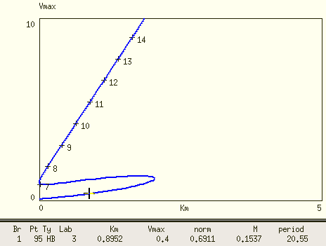

Time trajectories of Ptot are plotted for parameter values of the 4 blue dots.

Vmax=10, Km=0.1

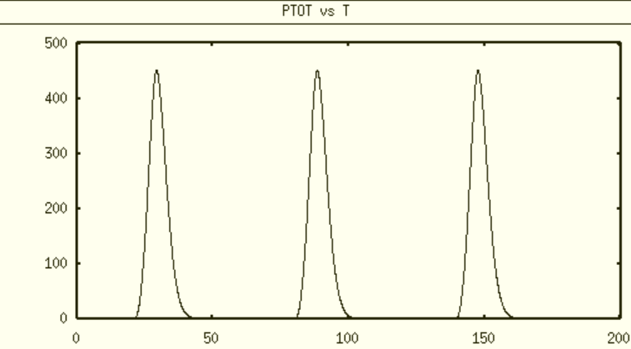

Vmax=5, Km=0.001

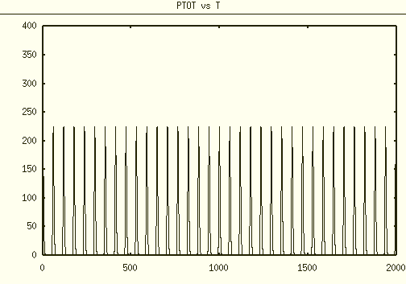

Vmax=5, Km=5

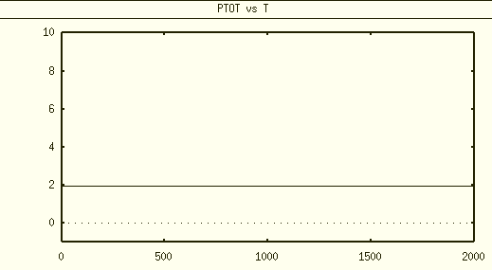

Vmax=0.4 Km=0.001

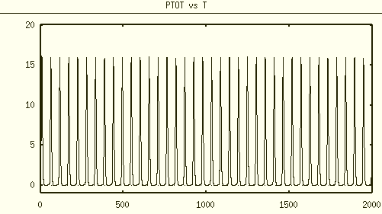

# 1-D bifurcation scanning is showing different result

Vmax=0.4

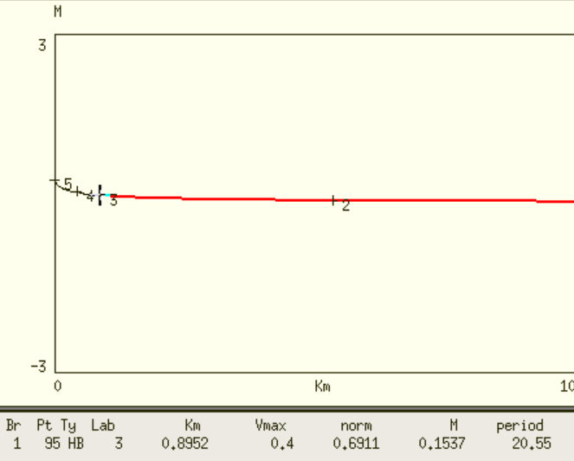

Vmax=10

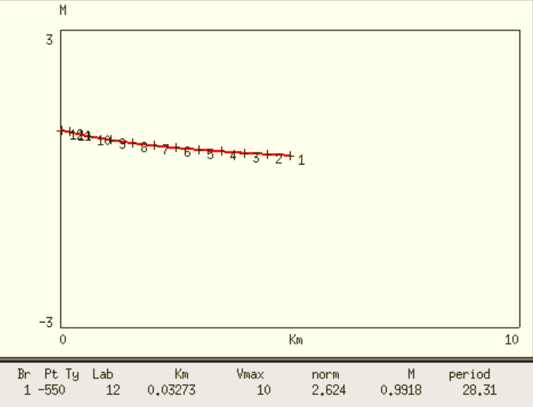

Vmax=5

